**Title**: Processing a Tentative Non-Confirmation

Overview: In some cases, the information from an employee's Form I-9 does not match government records and E-VERIFY will display a temporary case status that may require additional action. In these cases, E-VERIFY will return a response called a "Tentative Non-Confirmation (TNC)." A TNC response means that the Social Security Administration (SSA) and/or the U.S. Department of Homeland Security (DHS) could not confirm that the employee's information matches government records. It does not mean an employee is unauthorized to work or is an illegal immigrant as there are legitimate reasons why an employee may receive this result.

**Process Owner Unit**: UHR Operations, I-9 Preparers

**Last Updated**: 11/7/19

**Process**:

The following image from the USCIS website provides a high-level overview of the Tentative Non-Confirmation (TNC) process:

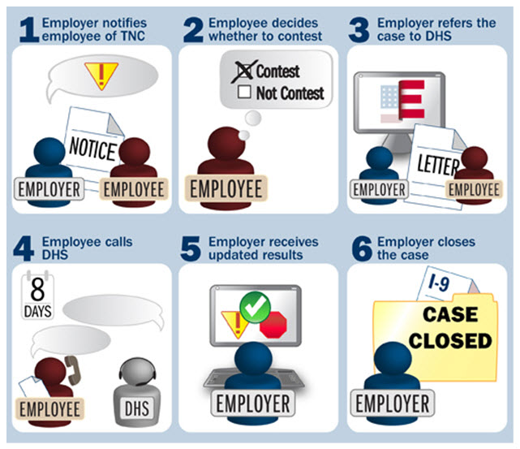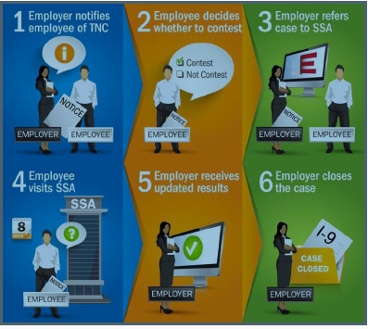

**I-9 Preparers must take the following actions:**

1. Notify the employee of TNC:
2. Contact the employee as soon as possible and schedule a time to meet.
3. Tell employee to bring original documents to the meeting.
4. Go into Guardian and open the employee’s I-9 record.
5. Click on the “**E-VERIFY**” tab.
6. Click on the link in the “**Date Created**” column to open the E-Verify case.
7. Click on the “**Further Action Notice**” link in the “**Employment Authorization Undetermined – Process Tentative Nonconfirmation (TNC)**” section.
8. View and print the notice to present to the employee.
9. Click the checkbox (I have notified this employee of the TNC) in the “**Process In-Person with Employee**” section. This automatically records the date and time you contacted the employee in the system. Check the box regardless of whether or not the employee responded to you. (Note: This step is very important. Employers are required to notify employees of a TNC within a reasonable time period. )
10. Review the current I-9 for errors:
    1. If an error is found, contact UHR to close the E-VERIFY case, amend the I-9, and submit the I-9 to E-VERIFY again.  After UHR is done, you must review the new E-VERIFY response and continue the I-9 process.
    2. If no errors are found, then move to Step 3 below to process the TNC.
11. Process the TNC: (Note: If the employee is out of state or is unable to meet with you, contact UHR.)
    1. Go into Guardian and open the employee’s I-9 record.
    2. Click on the “**E-VERIFY**” tab.
    3. Click on the link in the “**Date Created**” column to the open the current E-VERIFY submission.
    4. Review the information in the “**Employment Authorization Undetermined – Process Tentative Nonconfirmation (TNC)**” section.
    5. Click in the box next to the statement “**I have notified this employee of the TNC**” to activate the “**Process TNC**” button.
    6. Click on the “**Process TNC**” button. A screen will display showing options “**Employee will take action**” or “**Employee will not take action**”.
12. Indicate whether employee contests or does not contest TNC:
    1. If the employee chooses to not take action, click on the “**Employee will not take action**” button. (**Note: The employee should be terminated immediately with no civil or criminal liability as noted under “Responsibilities of the Employer” in the Memorandum of Understanding.  You must contact UHR as soon as possible.)**
    2. If the employee chooses to take action, click the “**Employee will take action**” button. You will see a screen where the employee must click the box that says, “**I will take action to resolve this E-Verify case**”. The employee will then click the button to “**sign the notification**”. (Note: employer no longer has to sign the FAN Letter)
13. Click on the “**Further Action Notice**” link to open a PDF of the Notice.
14. Print the signed Further Action Notice and give it to the employee. (Note: The notice will contain electronic signature of the employee. You do not need to print a copy of the signed notice for your records because an electronic copy is stored in the system.)
15. Close the PDF window.
16. Click on the *“***Initiate Referral**” button.
17. Review and Print the TNC Referral Date Confirmation
18. Click on the “**RDC Letter**” link to open a PDF of the Referral Date Confirmation.
19. Print the SSA or DHS Referral Date Confirmation and give it to the employee. (This letter provides the employee instructions for next steps and the 8 day deadline for reporting to SSA or DHS).
20. Click on the “**Referral Given**” button. (Note: this will notify E-Verify that the referral has been provided to the employee).

Click on the E-VERIFY “**Overview**” tab and make sure the text indicates that the case is pending further action. The “**Case Status**” box will confirm the date, the TNC was initiated on.

1. Please note the following:

* The employee must follow the instructions in the letter to resolve the issue by the deadline noted in the letter.
* The employer **cannot** take action against the employee while the employee resolves the case during the time allotted to do so. The employee may begin to work while this issue is being resolved.
* If the employee does not contact the federal government by the deadline, then the employee should be terminated.

1. After the employee resolves the issue with the government, you should monitor the employee’s E-VERIFY status to see if the status has been updated.  It may take anywhere from 3 days to a couple of weeks.
2. Take appropriate action after the E-VERIFY status is updated. Follow the instructions below to close the case.
3. Attach photo documents, if required: (Note: The system may prompt you to attach a copy of the photo document presented by the employee in order for it to be sent to DHS or SSA as part of the referral process. If this happens, a box titled “**Document Selection & Referral**” will be displayed and you must do the following:
4. Click on the “**Document Selection**” button.
5. You will see a split screen with two options:

* **“A. Send Document by Mail”**
* “**B. Upload Digital Copy of Document**”

You **must** use option “**B**.”

1. Click on the appropriate radio button to select the photo document from the list. If you do not see files listed, it may be because:

* Files not attached. If not, enter the employee record and attach the document to the I-9 record via the “**OnDocs**” tab.
* Attached files are not in the correct format. If necessary, contact your campus OIT Help Desk for assistance with file conversion and/or scanning.

1. Close the E-VERIFY case: (Note: This is done after E-VERIFY returns the final response. Remember to view the “**Top Pending E-VERIFY Actions**” in your Guardian Dashboard periodically to see if the status of the case has been updated by E-VERIFY. It may take between three (3) days and a few weeks for the issue to be resolved.)
2. Go into the employee’s E-VERIFY record.
3. If the case comes back “**employment authorized**”, the system will auto-close the record.
4. If the current status is “**Final Non-Confirmation**”, you must still close the case. (Note: This employee is **not** authorized to work and you **must** contact UHR about next steps.)